# **Department of Computer Science and Engineering Islamic University of Technology (IUT)** A subsidiary organ of OIC

# **Lab Report 04**

# CSE 4512: Computer Networks Lab

## 

## **Name: Rowshan Mannan Oni Student ID: 210042145 Section: SWE Semester: SUMMER Academic Year: 2023-2024**

**Date of Submission: 2/7/2024**

### **Title:** Understanding the basics of Variable Length Subnet Mask (VLSM) and VLANs and Inter-VLAN communication

### **Objectives**:

1. Define and describe the concept of VLAN
2. Describe the advantages of VLAN
3. Design and implement Inter-VLAN routing

### **Diagram of the experiment:**

(Provide screenshot of the final network topology. Make sure to label the network components.)

**TASK #01:**

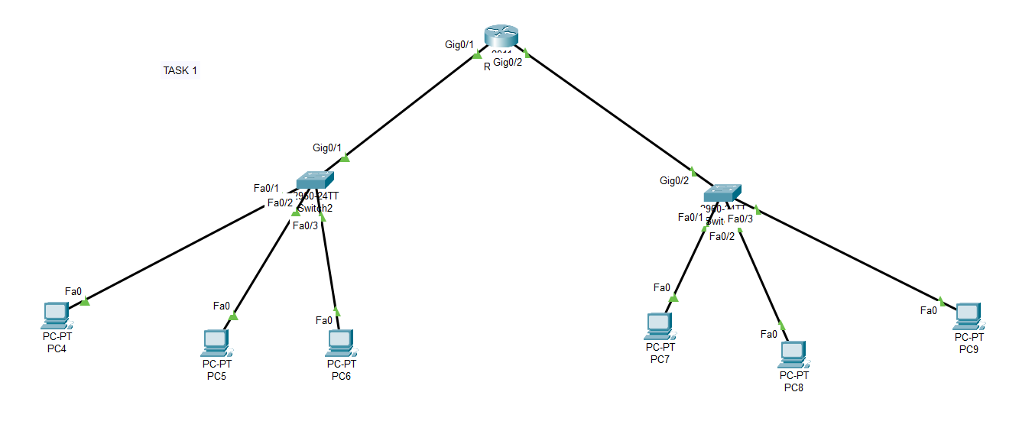

**TASK #02:**

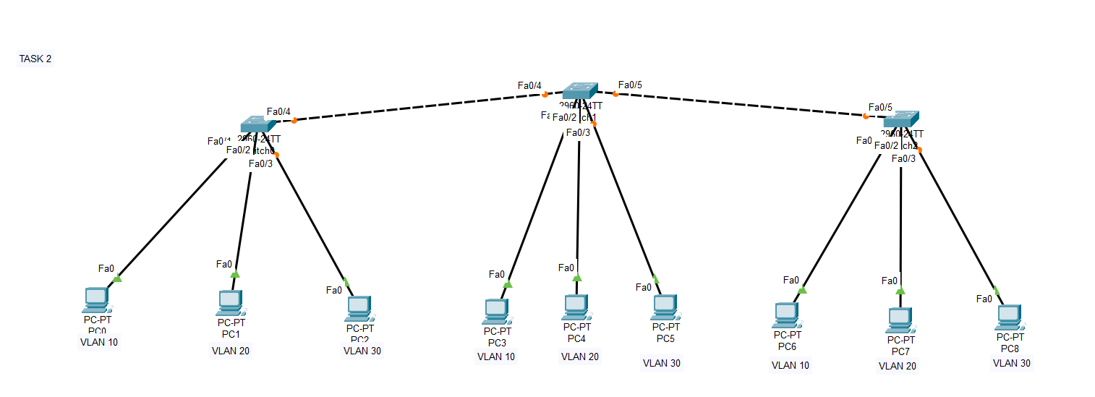

### **Working Procedure:**

**(**Explain in brief how you completed the tasks. Provide necessary screenshots of used commands for each task.)

**TASK #01:**

**Determine the Subnet Mask:** Since Y = 45, we need to find a subnet mask that can accommodate at least 45 hosts per network. The closest power of 2 greater than 45 is 64 (2^6 = 64), so we need at least 6 host bits. This results in a subnet mask of /26 (32 - 6 = 26). A subnet mask of /26 (255.255.255.192) would suffice.

**Identify the Network Address:** Look at the existing network addresses in the topology and choose a new network address that is not being used. Ensure that it falls within the appropriate range according to the subnet mask.

**Configure the Router:** Add a new subnet to the router's routing table with the chosen network address and the appropriate subnet mask.

Router(config)# interface <interface_name>

Router(config-if)# ip address 192.168.55.1 255.255.255.192

Router(config-if)# no shutdown

**Assign IP Addresses:** Assign IP addresses to the devices on the new network, ensuring that they fall within the chosen network address and subnet mask. Make sure to avoid any conflicts with existing IP addresses.

**Connect Devices:** Physically connect at least one PC to the new network. Ensure that the PC's network settings are configured with the appropriate IP address and subnet mask.

**Test Connectivity:** Ping from the newly added PC to other PCs within the existing network and vice versa. Verify that communication is successful.

**TASK #02:**

**Configure VLANs on Switches:** Configure VLANs on the switches and assign ports to each VLAN. For example:

Switch1(config)# vlan 10

Switch1(config-vlan)# name Students

Switch1(config)# vlan 20

Switch1(config-vlan)# name Teachers

Switch1(config)# vlan 30

Switch1(config-vlan)# name Admin

**Configure Interfaces on Switches:** Configure the interfaces those interfaces that will be used by respective vlans. For example:

Switch1(config)# interface FastEthernet 0/1

Switch1(config-if)# switchport mode access

Switch1(config-if)# switchport access vlan 10

**Assign IP Addresses:** Assign IP addresses to the devices on the new network. Make sure to avoid any conflicts with existing IP addresses.

**Test Connectivity:** Ping from the newly added PC to other PCs within the existing network and vice versa. Verify that communication is successful.

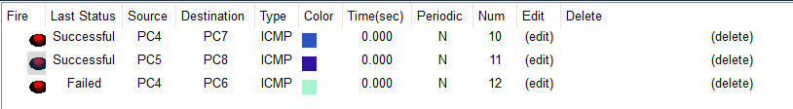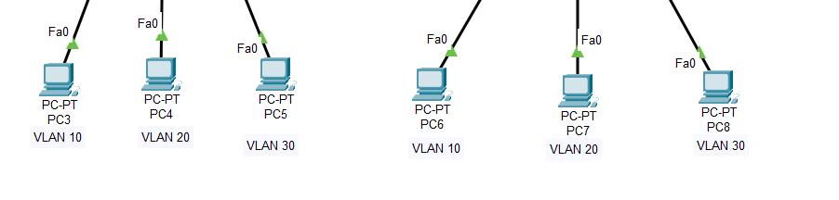

### **Questions (Answer to the point)**:

* + - 1. How many host bits are needed in the largest required subnet?

**Ans:** Number of host bits=log2(Number of hosts+2)

* + - 1. How many VLANs need to be configured to each of the switches?

**Ans:**

* + - 1. Which interfaces need Access Link?

**Ans:** Any interfaces on switches that directly connect to PCs or other end devices would typically require access links.

* + - 1. Which interfaces need Trunk Link?

**Ans:** Interfaces connecting switches to each other or to routers typically need trunk links.

* + - 1. After configuring VLAN, what will happen if we broadcast?

**Ans:** When a broadcast occurs after configuring VLANs, the broadcast traffic will only be forwarded within the VLAN in which it originated. Other VLANs will not receive the broadcast traffic, reducing unnecessary network traffic and improving network efficiency and security.

### **Challenges (if any):**

The task was seemingly easy.

### 